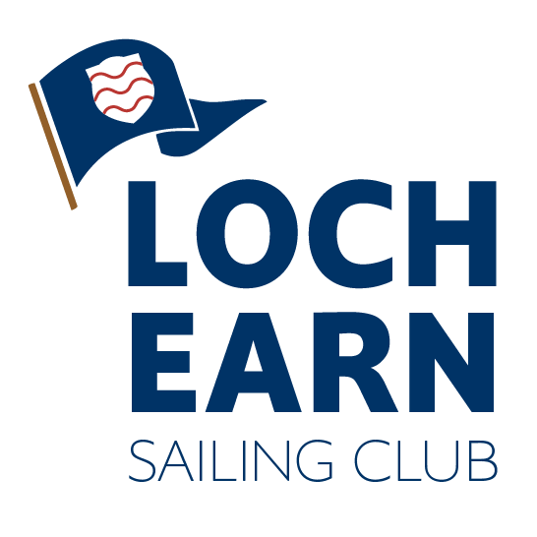
Loch Earn Sailing Club Challenger Traveller 2023 Sailing Instructions
26/08/23 - 27/08/2023
1. Rules
The regatta shall be governed by the racing rules of sailing RRS 2021 - 2024, the prescriptions of the RYA, the rules of the relevant class and the Sailing Instructions.

2. Entries
The safety of a boat and her entire management including insurance shall be the sole responsibility of the owner / person in charge who must ensure that the boat and crew are adequate to face the conditions that may arise in the course of the race. Neither these sailing instructions nor any inspection of the boat limits or reduces the absolute responsibility of the owner / person in charge for the crew, the boat and her management. The race organisers shall not be responsible for any loss, damage, death or personal injury howsoever caused to the owner / person in charge or crew, as a result of their taking part in the race or races. Moreover, every owner / person in charge warrants the suitability of the boat for the race or races.
Personal buoyancy will be worn at all times, while on the water.

3.Notices to Competitors
Notices to competitors shall be posted on the official notice board located in the clubhouse foyer. This will be signalled by flying flag L from the flagpole at the starter’s hut.

4. Postponements made onshore
Pennant ‘AP’ with two sound signals (one when lowered) indicates “the race is postponed”. When boats are ashore, the warning signal will be made not less than 20 minutes after the AP is lowered.

5. Changes to Sailing Instructions
Any changes to the sailing instructions shall be posted one hour before the start of the race they will affect.

6. Schedule of Races

Races are scheduled as follows. The intention is to sail 4 races both days and 6 on the Sunday for the Rs400s provided conditions allow. The Rs400s will have a break after 3 races provided all 6 races are sailed. RS400s will aim to sail 2 races before the other fleets join. Should the start of race 5 for other fleets be delayed, the flag AP will be displayed in alignment with section 4.

No fewer than 2 races each day will be sailed unless racing is abandoned due to adverse weather conditions.

Dingy, Keelboat, Wazsp and Enterprise Fleets

Race | Day | Warning Signal | First Start
Race 1-3* | Saturday | 10:54 | 11:00
Race 4-6* | Sunday | 10:54 | 11:00

* The number of races sailed will depend on the weather conditions

7. Briefing
The Briefing will be held at 1000 hours on Saturday from the patio. A horn will sound at the time of the breifing

8. Racing Area
The racing area is shown on the course chart issued.

9. The Course
Courses will be set by the OOD using the fixed club racing marks as shown on the course card issued to competitors.

The course will be displayed on the board beside the starter’s hut prior to the warning signal. On the Course board, marks to be passed to port will be shown on a RED tile and those to be passed to starboard shall be shown on a GREEN tile. The intention is to have up to 5 starts depending on the number of boats on the start line.

The board will display as follows:
S1 – Challenger Fleet
H/C - Club cup fleet for the day

Should there be a change to the above, this will be communicated to the sailors during the briefing
and in accordance with section 3.

Should the Race Officer consider it necessary to change the course after the warning signal, the race will be postponed, and flag AP displayed in alignment with section 4.

Please check the course board in between races as the course may change between races.

Racers must pass through the start line as detailed in section 11 each lap

10. Marks
The courses will use the fixed club marks indicated on the course chart. Positions of the marks are approximate. All marks display the appropriate number/letter. It is the responsibility of each competitor to ensure they are aware of the actual location of marks used. Temporary marks will not be used

11. The Start
- With the fixed start line and marks at Loch Earn a 3 minute start sequence is used
- This alters rule 26
- Class flags & starting order will be confirmed at the briefing. In the event of a general recall, the class involved will drop to the rear of the starting order continuing in the three-minute sequence
- The Starting line will be between the orange pole on the shore in front of the race hut and mark X

12. Mark Boats
Mark boats may be used for the first race of each day. This is subject to the availability of volunteers.

13. The Finish
The finishing line will be between the orange pole at the front of the starter’s hut and mark X

14. Shortened Course
When a course is shortened Flag S will be displayed, accompanied by the relevant class flag and 2 sound
signals. The leading boat will finish at the end of the round still to be completed.

15. Time Limit & Target Race Times
The time limit will be 95 minutes which may be extended at the discretion of the Race Officer. This changes rule 35. The target time for the 1st placed boat will be +/- 45 minutes. “Average laps” may be used at the Race Officer’s discretion.

No warning signal will be made after 15:00 on Sunday.

16. Protests
Protest forms are available at the race office and must be delivered there within 30 minutes after the last boat in your class has finished the last race of the day.

17. Scoring
The ‘Low Point’ scoring system, (rule A4), will apply. 8 races scheduled*, 1 discard will apply after 4 races sailed. 2 races shall constitute a series.

18. Ties
Ties will be broken in favour of the boat with most 1st places, then most 2nd places and so on. If the tie remains, the best result in the last race will decide the winner.

19. Prizes

Prizes will be awarded as per the NOR & at the discretion of the organisers.

